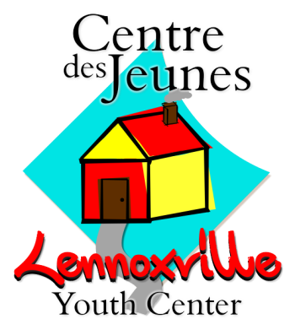
Volunteer Application

Last Name: | Click here to enter text. | First Name: | Click here to enter text.

Mailing Address
Click here to enter text. | Click here to enter text. | Click here to enter text. | Click here to enter text.
Street Number | City | Province | Postal Code

Phone Number: | Click here to enter text.
E-Mail Address: | Click here to enter text.
Birthdate:
 | YEAR | MONTH | DAY
Correspondence: | ☐ English ☐ Français

Areas of Interest: | ☐ Sports ☐ Arts ☐ Cooking ☐ Workshops ☐ Tutoring  ☐ Arts & Crafts ☐ Games ☐ Board of Directors ☐ Other (Specify below)  Click here to enter text.
 | Click here to enter text.
Availabilities: | DAY MON TUE WED THU FRI SAT  AM ☐ ☐ ☐ ☐ ☐ ☐  PM ☐ ☐ ☐ ☐ ☐ ☐
`
Do you consent to a criminal record verification administered by the Sherbrooke Police Service? ☐ Yes ☐ No

Please send the completed application form, along with a current CV and cover letter, to the attention of Kohl Kelso, Coordinator at the following e-mail address: kkelso@lennoxvilleyouthcenter.org.

